Project Design Phase-II
Technology Stack (Architecture & Stack)

Date | 30 September 2026
Team ID | SWTID-2026-1437
Project Name | AI WeatherWise API
Maximum Marks | 4 Marks

Technical Architecture:
The Deliverable shall include the architectural diagram as below and the information as per the table1 & table 2
Technical Architecture - AI WeatherWise API
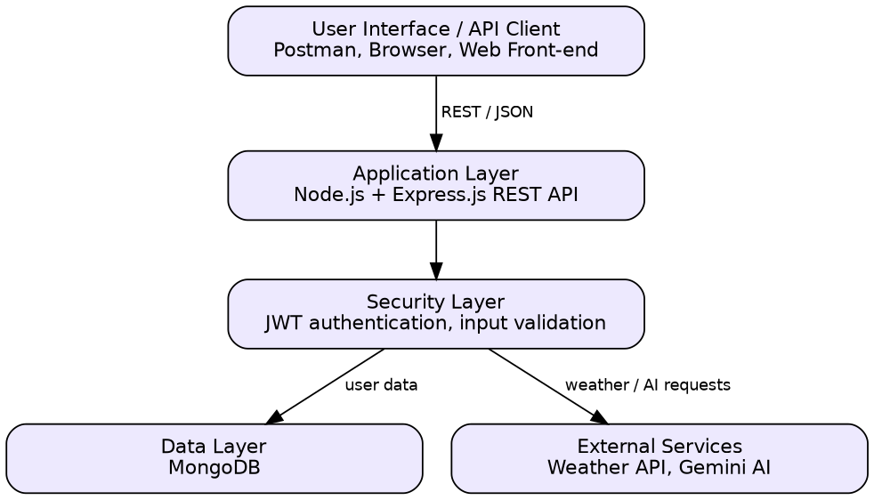
Table-1 : Components & Technologies:
S.No | Component | Description | Technology
 | User Interface | Users interact with the API through an API client or a front-end that sends REST requests | Postman / Browser, JSON over HTTP
 | Application Logic-1 | User registration, login, authentication and profile | Node.js, Express.js
 | Application Logic-2 | Fetching and returning weather information for a city | Node.js, Express.js
 | Application Logic-3 | Generating AI-based weather insights | Node.js, Gemini AI
 | Database | Stores user data (NoSQL documents) | MongoDB
 | Cloud Database | Optional hosted database service | MongoDB Atlas (optional)
 | File Storage | No file storage required; configuration is kept in environment (.env) files | Local filesystem
 | External API-1 | Provides current weather data for a city | Weather API
 | External API-2 | Provides AI-generated weather insights | Gemini AI API
 | Machine Learning Model | Pre-trained generative AI model used to produce weather insights | Google Gemini
 | Infrastructure (Server / Cloud) | Application deployment on local system / cloud  Local Server Configuration: Node.js server with local/remote MongoDB  Cloud Server Configuration: any Node.js hosting service | Local, Cloud (optional)

Table-2: Application Characteristics:
S.No | Characteristics | Description | Technology
 | Open-Source Frameworks | Node.js runtime and Express.js web framework with MongoDB | Node.js, Express.js, MongoDB
 | Security Implementations | JWT-based authentication, protected routes, input validation, API keys stored in environment variables | JWT, environment variables
 | Scalable Architecture | Layered design (client, API, database); stateless API allows horizontal scaling | 3-tier architecture
 | Availability | Stateless API can run on multiple instances behind a load balancer; database persists data | Node.js, MongoDB
 | Performance | Non-blocking asynchronous I/O in Node.js; responses can be cached if needed | Node.js (async I/O)

References:
https://c4model.com/
https://developer.ibm.com/patterns/online-order-processing-system-during-pandemic/
https://www.ibm.com/cloud/architecture
https://aws.amazon.com/architecture
https://medium.com/the-internal-startup/how-to-draw-useful-technical-architecture-diagrams-2d20c9fda90d

